

Rossman store sales

Forecast sales using store, promotion, and competitor data



CIS 5270: Business Intelligence (Spring 2017)

By: Niklas Melcher & Yashaswi Ananth

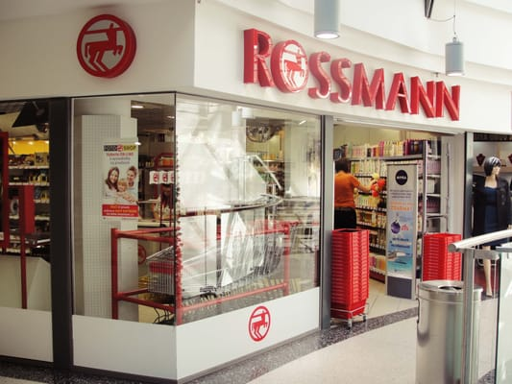

SUBMITTED TO – DR. SHILPA BALAN

CALIFORNIA STATE UNIVERSITY, LOS ANGELES.

**OBJECTIVE OF THE STUDY:**

Store sales are influenced by many factors, including promotions, competition, school and state holidays, seasonality, and locality. Analysis of such data can provide stores with information to make confident inventories and merchandise decisions that will lead to improved sales, profit, efficiency and customer satisfaction. There is a scope of gaining better knowledge determining best sellers; figuring out what prices worked best; better forecast future sales; take product assortments into account; discover new products to add to the assortment; and much more.

A very interesting feature in the dataset is the promotion variable. Sales promotions are “techniques and devices commonly used on a temporary basis, to make goods and services more attractive to distributors or final customers by providing them with some additional benefit or inducement (incentive) or the expectations of such a benefit, whether in cash, in kind (nature) and/or services, whether immediately or at a later time, whether freely or conditionally [1]”. Since sales promotions have become a vital tool for marketers and its importance has been increasing, it is very interesting to analyze how promotions will affect the sales of a company and if there is a pattern between a promotion and e.g. a school holiday or state holiday. [2]

**ABOUT THE DATASET:**

Data was gathered from Rossman which is Germany’s second largest drug store chain with 3,000 other stores in Europe. It contains day-to-day store data such as the number of customers in a given day, turnover sales, distance to the nearest competition store, were the store sales were affected due to a public holiday or closure of schools etc. In summary, it contains 1017210 rows and 9 variables.

The dataset file is of the size 37.166 KB and is in a .CSV format.

**DATASET URL:**

<https://www.kaggle.com/c/rossmann-store-sales/data>

Choose ‘train.csv.zip’

**INTERESTING INSIGHTS THAT CAN BE DERIVED:**

1. Which day of the week generally has more sales turnover?
2. What was the increase or decrease in store sales on a promo day as compared to a normal day?
3. To what extent has the store sales been affected since the time the nearest competitor started business?

**REFERENCES:**

1. Boddewyn, Jean J., and Monica Leardi. "Sales promotions: Practice, regulation and self-regulation around the world." International Journal of Advertising 8.4 (1989), p. 365.
2. Chaharsoughi, Shahriar Ansari. "Effect of sales promotion on consumer behavior based on culture." African Journal Of Business Management 6.1 (2012), p. 1.